KB11N -

Functionality
You can repost primary costs manually using transaction-based repostings, whereby the original cost element is always retained. This function is designed mainly to adjust posting errors where an incorrect cost center has been used.

Scenario
The incorrect cost center was used for a specific transaction. Reposting is done to the correct cost center.

Requirements
None.

Menu Path | Accounting → Controlling → Cost Center Accounting → Actual Postings → Manual Reposting of Costs → KB11N - Enter
Transaction Code | KB11N

1. Double Click on KB11N - Enter

7 | 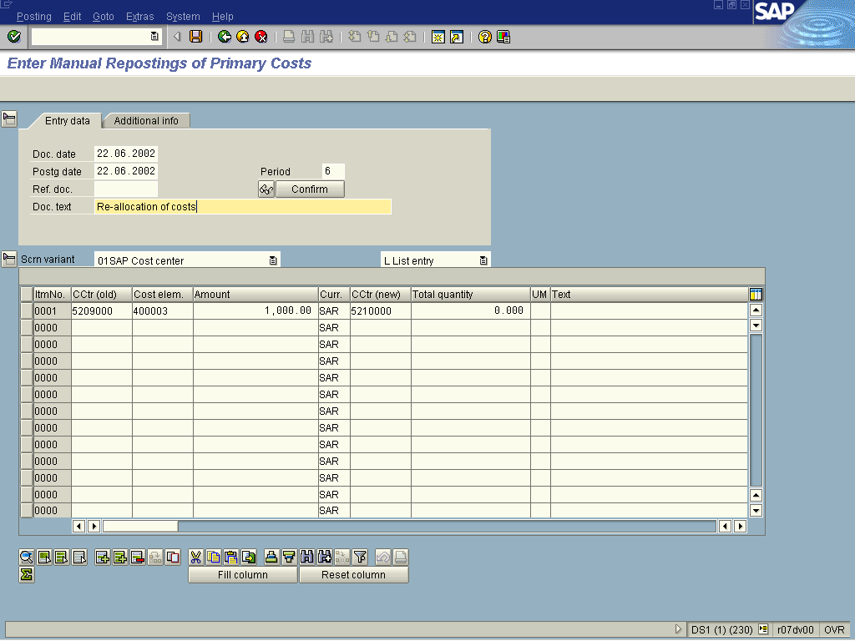
2. Update the following fields:

Field Name | Description | Values
Postg date | Posting date of the document. | Example: 05.06.2002
Doc. Text | Document Text is used to briefly describe the transaction. | Re-allocation of costs
CCtr (old) | The old Cost Center. | Example: 5209000
Cost elem. | Cost element number. | Example: 400003
Amount | Amount of the line item | Example: 1000
CCtr (new) | Description of the Cost Center. | Example: 5210000
3. Click Enter to validate your entries.
4. Click Save

